**Assignment -1**

Python Programming

**SMART FASHION RECOMMENDER APPLICATION**

|  |  |
| --- | --- |
| Assignment Date | 19 September 2022 |
| Team ID | PNT2022TMID53909 |
| Student Name | Sunil Raja A |
| Student Roll Number | 95071912100 |
| Maximum Marks | 2 Marks |

**Question-1:**

Create registration page in html with username, email and phone number and by using POST method display it in next html page.

**Solution:**

**Program:**

**index.html:**

<!DOCTYPE html>

<html>

<head>

  <title>Login | Smart Fashion Recommender</title>

  <link rel="stylesheet" type="text/css" href="style.css">

  <link href="https://fonts.googleapis.com/css?family=Nunito:400,600,700,800&display=swap" rel="stylesheet">

</head>

<body>

  <div class="cont">

    <div class="form sign-in">

      <h2>Sign In</h2>

      <form action="login" method="post">

        <label>

          <span>Name</span>

          <input type="text" name="name" required />

        </label>

        <label>

          <span>Email Address</span>

          <input type="email" name="email" required />

        </label>

        <label>

          <span>Phone Number</span>

          <input type="number" name="phone" required />

        </label>

        <button type="submit" class="submit">Sign In</button>

      </form>

      <p class="forgot-pass">Forgot Password ?</p>

      <div class="social-media">

        <ul>

          <li><a href="https://www.facebook.com/login.php/"><img src="images/facebook.png"></a></li>

          <li><a href="https://twitter.com/i/flow/login"><img src="images/twitter.png"></li></a></li>

          <li><a href="https://www.linkedin.com/login"><img src="images/linkedin.png"></a></li>

          <li><a href="https://www.instagram.com/accounts/login/"><img src="images/instagram.png"></a></li>

        </ul>

      </div>

    </div>

    <div class="sub-cont">

      <div class="img">

        <div class="img-text m-up">

          <h2>New here?</h2>

          <p>Sign up and discover great amount of new opportunities!</p>

        </div>

        <div class="img-text m-in">

          <h2>One of us?</h2>

          <p>If you already has an account, just sign in. We've missed you!</p>

        </div>

        <div class="img-btn">

          <span class="m-up">Sign Up</span>

          <span class="m-in">Sign In</span>

        </div>

      </div>

      <div class="form sign-up">

        <h2>Sign Up</h2>

        <form action="login" method="post">

          <label>

            <span>Name</span>

            <input type="text" name="name" required>

          </label>

          <label>

            <span>Email</span>

            <input type="email" name="email" required>

          </label>

           <label>

            <span>Phone</span>

            <input type="number" name="phone" required>

          </label>

          <label>

            <span>Password</span>

            <input type="password" required>

          </label>

          <button type="submit" class="submit">Sign Up Now</button>

        </form>

      </div>

    </div>

  </div>

  <script type="text/javascript" src="script.js"></script>

</body>

</html>

**style.css:**

*, *:before, *:after{

  margin: 0;

  padding: 0;

  box-sizing: border-box;

  font-family: 'Nunito', sans-serif;

}

body{

  width: 100%;

  height: 100vh;

  display: flex;

  justify-content: center;

  align-items: center;

  background: -webkit-linear-gradient(left, #7579ff, #b224ef);

  font-family: 'Nunito', sans-serif;

}

input, button{

  border:none;

  outline: none;

  background: none;

}

.cont{

  overflow: hidden;

  position: relative;

  width: 900px;

  height: 600px;

  background: #fff;

  box-shadow: 0 19px 38px rgba(0, 0, 0, 0.30), 0 15px 12px rgba(0, 0, 0, 0.22);

}

.form{

  position: relative;

  width: 640px;

  height: 100%;

  padding: 50px 30px;

  -webkit-transition:-webkit-transform 1.2s ease-in-out;

  transition: -webkit-transform 1.2s ease-in-out;

  transition: transform 1.2s ease-in-out;

  transition: transform 1.2s ease-in-out, -webkit-transform 1.2s ease-in-out;

}

h2{

  width: 100%;

  font-size: 30px;

  text-align: center;

}

label{

  display: block;

  width: 260px;

  margin: 25px auto 0;

  text-align: center;

}

label span{

  font-size: 14px;

  font-weight: 600;

  color: #505f75;

  text-transform: uppercase;

}

input{

  display: block;

  width: 100%;

  margin-top: 5px;

  font-size: 16px;

  padding-bottom: 5px;

  border-bottom: 1px solid rgba(109, 93, 93, 0.4);

  text-align: center;

  font-family: 'Nunito', sans-serif;

}

button{

  display: block;

  margin: 0 auto;

  width: 260px;

  height: 36px;

  border-radius: 30px;

  color: #fff;

  font-size: 15px;

  cursor: pointer;

}

.submit{

  margin-top: 40px;

  margin-bottom: 30px;

  text-transform: uppercase;

  font-weight: 600;

  font-family: 'Nunito', sans-serif;

  background: -webkit-linear-gradient(left, #7579ff, #b224ef);

}

.submit:hover{

  background: -webkit-linear-gradient(left, #b224ef, #7579ff);

}

.forgot-pass{

  margin-top: 15px;

  text-align: center;

  font-size: 14px;

  font-weight: 600;

  color: #0c0101;

  cursor: pointer;

}

.forgot-pass:hover{

  color: red;

}

.social-media{

  width: 100%;

  text-align: center;

  margin-top: 20px;

}

.social-media ul{

  list-style: none;

}

.social-media ul li{

  display: inline-block;

  cursor: pointer;

  margin: 25px 15px;

}

.social-media img{

  width: 40px;

  height: 40px;

}

.sub-cont{

  overflow: hidden;

  position: absolute;

  left: 640px;

  top: 0;

  width: 900px;

  height: 100%;

  padding-left: 260px;

  background: #fff;

  -webkit-transition: -webkit-transform 1.2s ease-in-out;

  transition: -webkit-transform 1.2s ease-in-out;

  transition: transform 1.2s ease-in-out;

}

.cont.s-signup .sub-cont{

  -webkit-transform:translate3d(-640px, 0, 0);

          transform:translate3d(-640px, 0, 0);

}

.img{

  overflow: hidden;

  z-index: 2;

  position: absolute;

  left: 0;

  top: 0;

  width: 260px;

  height: 100%;

  padding-top: 360px;

}

.img:before{

  content: '';

  position: absolute;

  right: 0;

  top: 0;

  width: 900px;

  height: 100%;

  background-image: url(images/bg.jpg);

  background-size: cover;

  transition: -webkit-transform 1.2s ease-in-out;

  transition: transform 1.2s ease-in-out, -webkit-transform 1.2s ease-in-out;

}

.img:after{

  content: '';

  position: absolute;

  left: 0;

  top: 0;

  width: 100%;

  height: 100%;

  background: rgba(0,0,0,0.3);

}

.cont.s-signup .img:before{

  -webkit-transform:translate3d(640px, 0, 0);

          transform:translate3d(640px, 0, 0);

}

.img-text{

  z-index: 2;

  position: absolute;

  left: 0;

  top: 50px;

  width: 100%;

  padding: 0 20px;

  text-align: center;

  color: #fff;

  -webkit-transition:-webkit-transform 1.2s ease-in-out;

  transition: -webkit-transform 1.2s ease-in-out;

  transition: transform 1.2s ease-in-out, -webkit-transform 1.2s ease-in-out;

}

.img-text h2{

  margin-bottom: 10px;

  font-weight: normal;

}

.img-text p{

  font-size: 14px;

  line-height: 1.5;

}

.cont.s-signup .img-text.m-up{

  -webkit-transform:translateX(520px);

          transform:translateX(520px);

}

.img-text.m-in{

  -webkit-transform:translateX(-520px);

          transform:translateX(-520px);

}

.cont.s-signup .img-text.m-in{

  -webkit-transform:translateX(0);

          transform:translateX(0);

}

.sign-in{

  padding-top: 65px;

  -webkit-transition-timing-function:ease-out;

          transition-timing-function:ease-out;

}

.cont.s-signup .sign-in{

  -webkit-transition-timing-function:ease-in-out;

          transition-timing-function:ease-in-out;

  -webkit-transition-duration:1.2s;

          transition-duration:1.2s;

  -webkit-transform:translate3d(640px, 0, 0);

          transform:translate3d(640px, 0, 0);

}

.img-btn{

  overflow: hidden;

  z-index: 2;

  position: relative;

  width: 100px;

  height: 36px;

  margin: 0 auto;

  background: transparent;

  color: #fff;

  text-transform: uppercase;

  font-size: 15px;

  cursor: pointer;

}

.img-btn:after{

  content: '';

  z-index: 2;

  position: absolute;

  left: 0;

  top: 0;

  width: 100%;

  height: 100%;

  border: 2px solid #fff;

  border-radius: 30px;

}

.img-btn span{

  position: absolute;

  left: 0;

  top: 0;

  display: -webkit-box;

  display: flex;

  -webkit-box-pack:center;

  justify-content: center;

  align-items: center;

  width: 100%;

  height: 100%;

  -webkit-transition:-webkit-transform 1.2s;

  transition: -webkit-transform 1.2s;

  transition: transform 1.2s;

  transition: transform 1.2s, -webkit-transform 1.2s;;

}

.img-btn span.m-in{

  -webkit-transform:translateY(-72px);

          transform:translateY(-72px);

}

.cont.s-signup .img-btn span.m-in{

  -webkit-transform:translateY(0);

          transform:translateY(0);

}

.cont.s-signup .img-btn span.m-up{

  -webkit-transform:translateY(72px);

          transform:translateY(72px);

}

.sign-up{

  -webkit-transform:translate3d(-900px, 0, 0);

          transform:translate3d(-900px, 0, 0);

}

.cont.s-signup .sign-up{

  -webkit-transform:translate3d(0, 0, 0);

          transform:translate3d(0, 0, 0);

}

**Question-2:**

Develop a flask program which should contain at least 5 packages used from pypi.org.

**Solution:**

**Program:**

**app.py**

from tkinter.tix import Form

from flask import Flask ,render_template,url_for,redirect,request

app = Flask(__name__)

@app.route('/')

def index():

    return render_template("index.html")

@app.route('/success/<name>/<phone>/<email>')

def success(name=None,phone=None,email=None):

    return " <h1>Registered Successfully</h1><h2>Your Details Are:-</h2>  {} <br>{} <br> {} ".format(name , phone ,email)

    #  '{} {} {}'.format(firstname, lastname, cellphone)

@app.route("/login",methods =['POST','GET'])

def login():

    if request.method == 'POST':

        user = request.form['name']

        email = request.form['email']

        phone = request.form['phone']

        return redirect(url_for("success", name = user ,phone = phone ,email = email ))

        # name = user ,phone = phone ,email = email

    else:

        user = request.args.get("input_name")

        return redirect(url_for("success",name=user))

if __name__ == '__main__':

    app.run(debug=True)

**Output:**

**Screenshots:**

1. **Registration Page:**

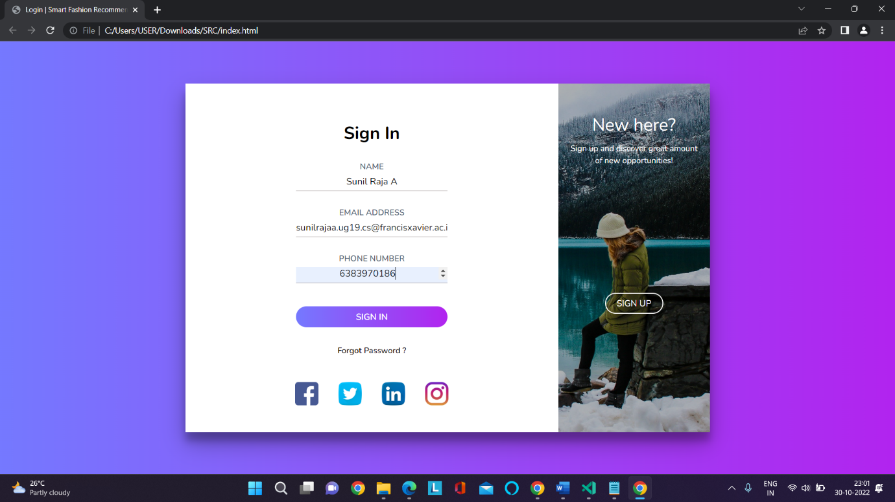

1. 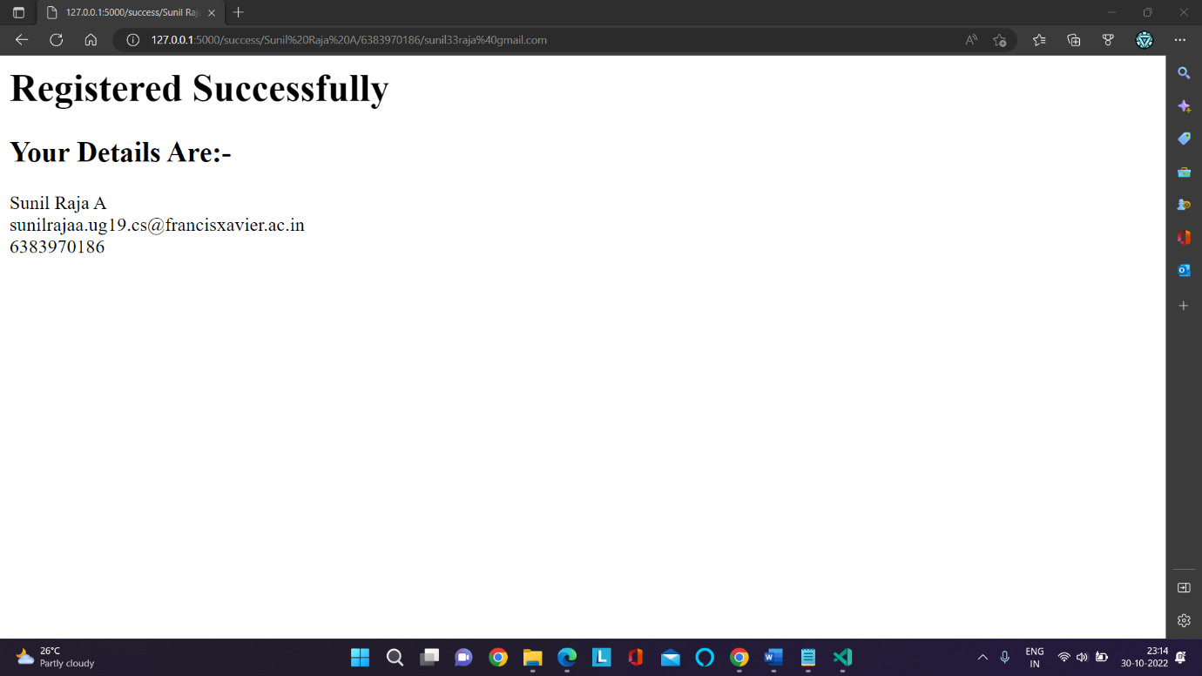**Registration Successful:**